

Name: Tahir Fareed

Roll No: SU92-BSAIM-F24-036

Section: BSAI (3A)

Subject: AI Lab

Task : 08

Min Max Algorithm documentation

1. Introduction
The Min-Max Algorithm is a fundamental concept in Artificial Intelligence, primarily used in game theory and decision-making. It helps in finding the optimal move for a player, assuming that the opponent also plays optimally. This algorithm uses the concept of minimizing the possible loss in a worst-case scenario.

2. Objective
The main objective of implementing the Min-Max Algorithm is to create a decision-making model that can evaluate all possible outcomes and choose the most beneficial one. It simulates the behavior of two players: one trying to maximize the score (MAX) and the other trying to minimize it (MIN).

3. Overview of Min-Max Algorithm
The Min-Max Algorithm works on the principle of recursive evaluation. It explores all possible moves using a tree structure, calculates scores for terminal states, and then propagates those scores backward to decide the optimal strategy.

4. Code Explanation
Below is an explanation of the provided code implementing the Min-Max Algorithm:
1. **Importing the math library**:
The code starts by importing the 'math' module to use mathematical functions like logarithm.
2. **Defining the function minimax()**:
The function takes the following parameters:
- curDepth: the current depth of the node
- nodeIndex: the index of the current node in the score list
- maxTurn: a boolean indicating whether it’s the maximizing player's turn
- scores: a list of final scores at the leaf nodes
- targetDepth: the depth of the tree
3. **Base condition**:
If the current depth is equal to the target depth, the function returns the score of the node.
4. **Recursive calls**:
- If it’s the MAX player’s turn, the function returns the maximum of two recursive calls.
- If it’s the MIN player’s turn, it returns the minimum of two recursive calls.
5. **Main section**:
- The scores list 'T' contains the leaf node values.
- The tree depth is calculated using log base 2 of the length of the score list.
- Finally, the optimal value is printed using the minimax function call.

5. Input and Output
**Input:**
A predefined list of numerical scores representing terminal node values in the decision tree.
**Output:**
The optimal score value for the maximizing player, based on recursive evaluation.

Output screenshot :
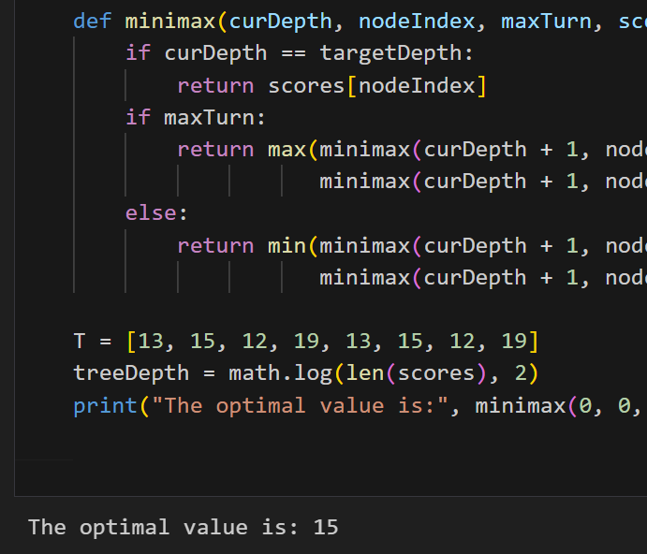

6. Working Flow
1. Initialize the score list.
2. Determine the depth of the decision tree.
3. Call the minimax() function with the initial parameters.
4. Recursively calculate scores for all possible outcomes.
5. Propagate the optimal values up to the root.
6. Print the final optimal value.

7. Conclusion
The Min-Max Algorithm is an essential tool for developing intelligent systems that make optimal decisions. Through recursive evaluation and logical reasoning, it ensures that a player can always choose the best possible move even when facing an intelligent opponent. The implementation demonstrates a clear understanding of recursion, tree structures, and decision-making logic.

